Hadoop Assignment -3
(Pawan Bisht 2018msbda006)

Q : Write a mapper and reducer for counting words from twitter data on different date and total number of words in a particular date ?

Solution :

Mapper :

#!/usr/bin/python3

import sys
text=[]
date=[]
for line in sys.stdin:
text.append(line.split(',')[0])
date.append(line.split(',')[1])
for i in range(1,len(date)):
date[i]=date[i].split(' ')[0]
for j in range(1,len(text)):
for i in text[j].split(' '):
if(len(i)==0): continue
else:
print(i+' '+date[j],',',1)

Output (Mapper)

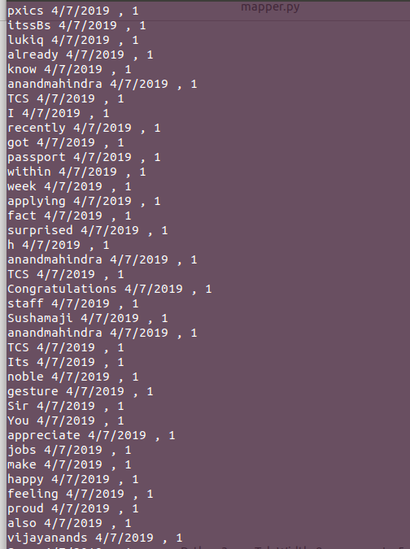

Reducer :

#!/usr/bin/python3

import sys

current_word = None
current_count = 1
d={}
for line in sys.stdin:
word,count=line.strip().split(",")
if current_word:
if word == current_word:
current_count += int(count)
else:
print (current_word, current_count)
current_count = 1

current_word = word

text,date=word.strip().split(" ")
if(date in d.keys()):
d[date]+=1
else:
d[date]=1
if current_count > 1:
print (current_word, current_count)
print("Number of total words in paticular dates are : ",d)

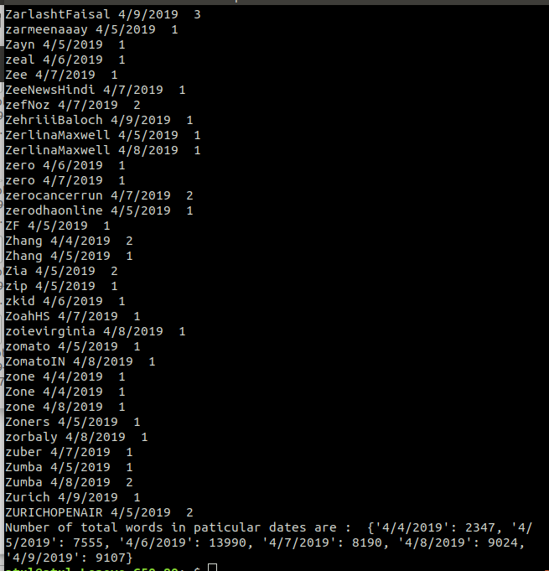
Output (Reducer )

